**Exp No-12 :** Linux Host Operating System

**AIM:** Create and configure VM image with a Host Operating system Linux using vm ware workstation.

**Material:**

● VM Workstation software.

● Configurations.

**Procedure:**

**Step 1:** 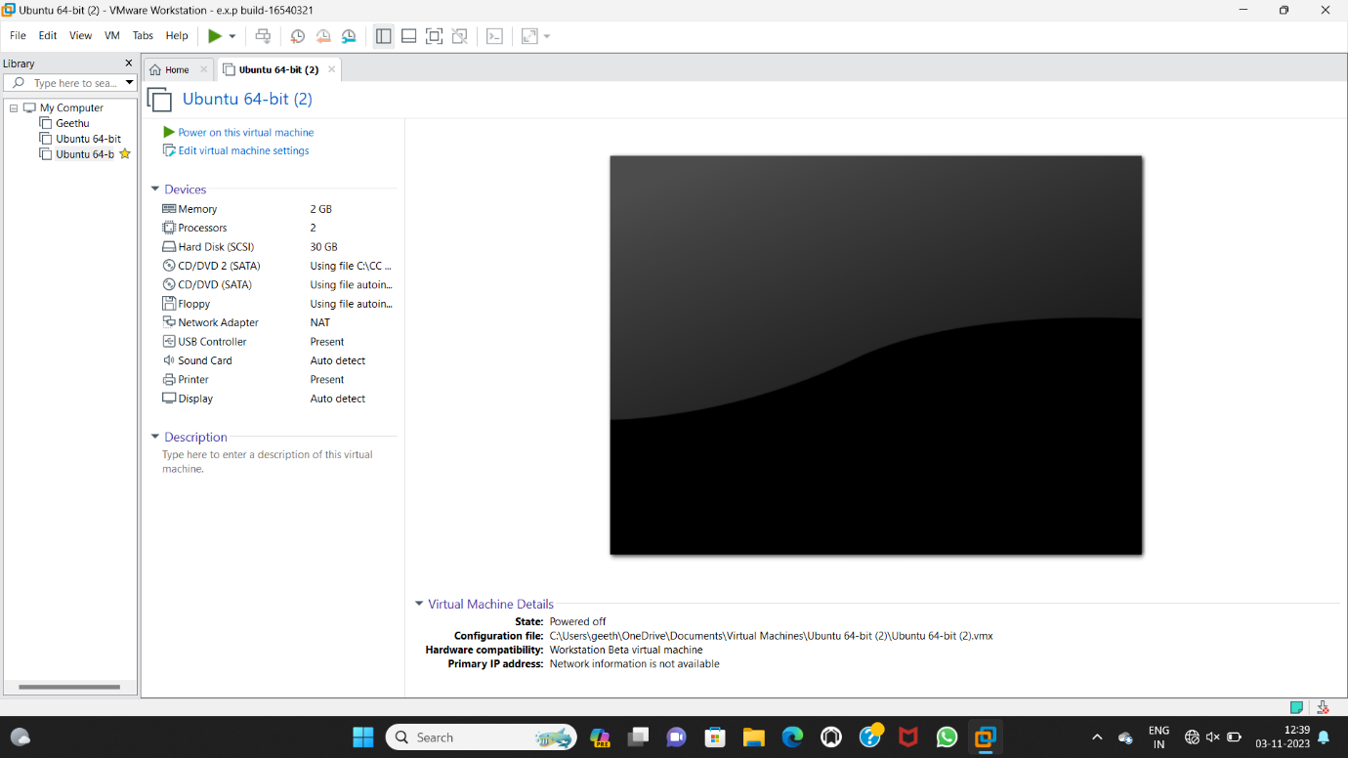

**Step 2:**

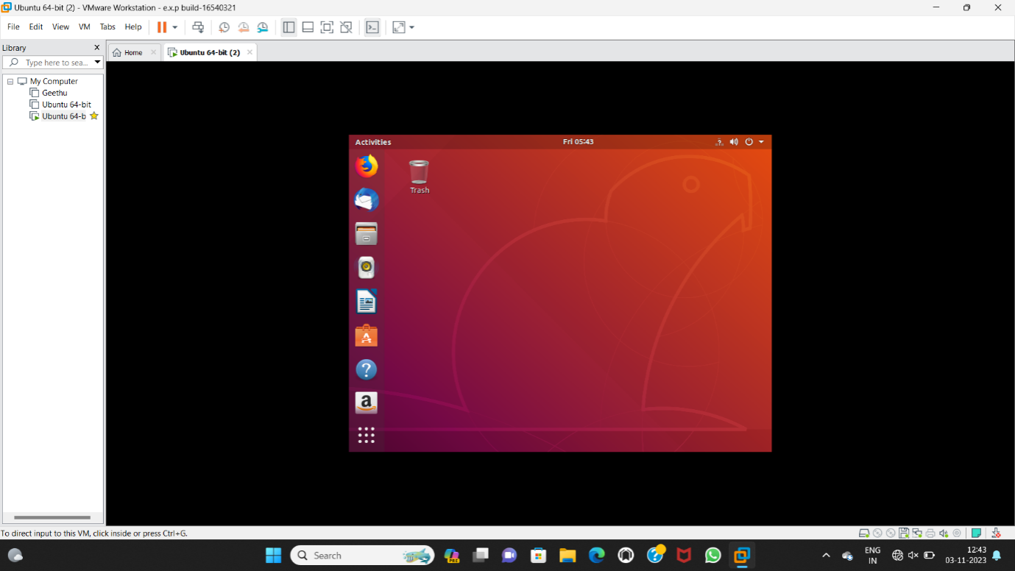

**Step 3:**

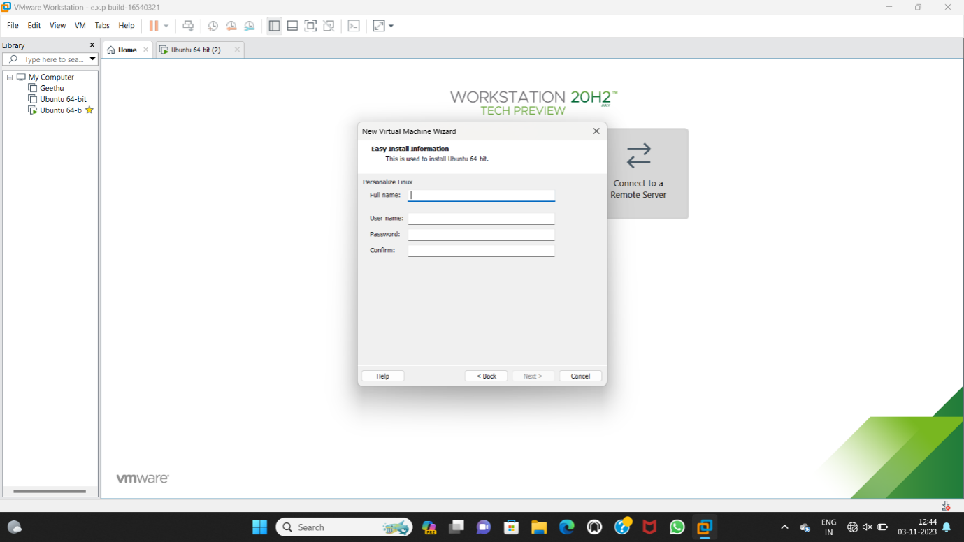

**Step 4:** 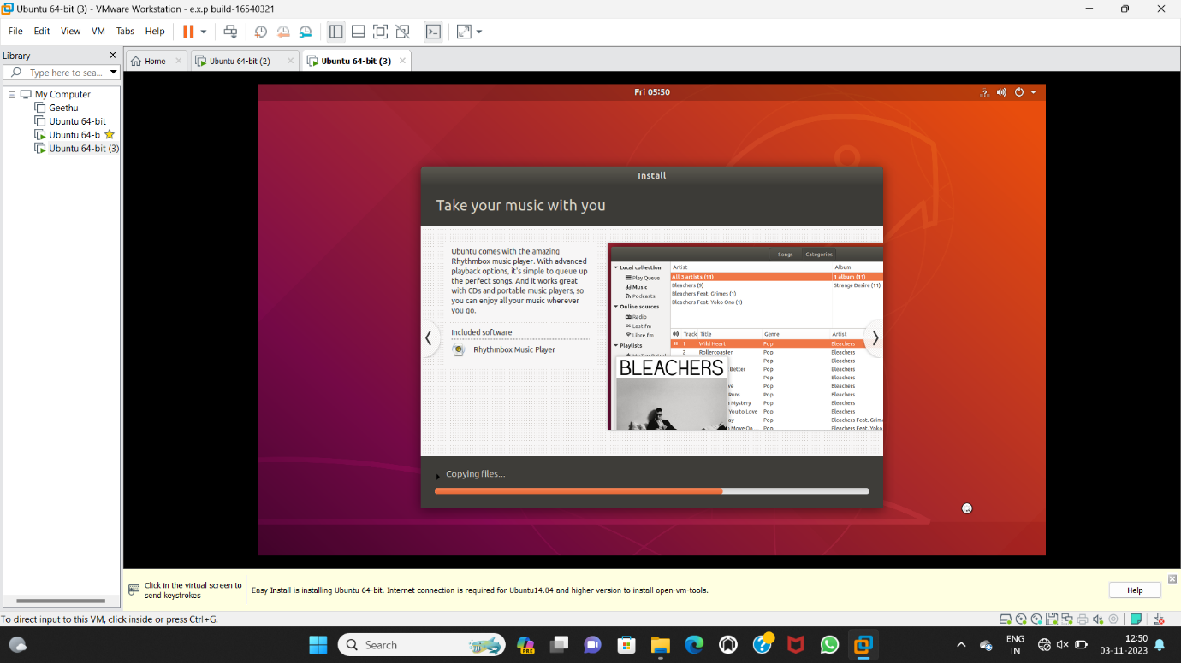

**Step 5:**

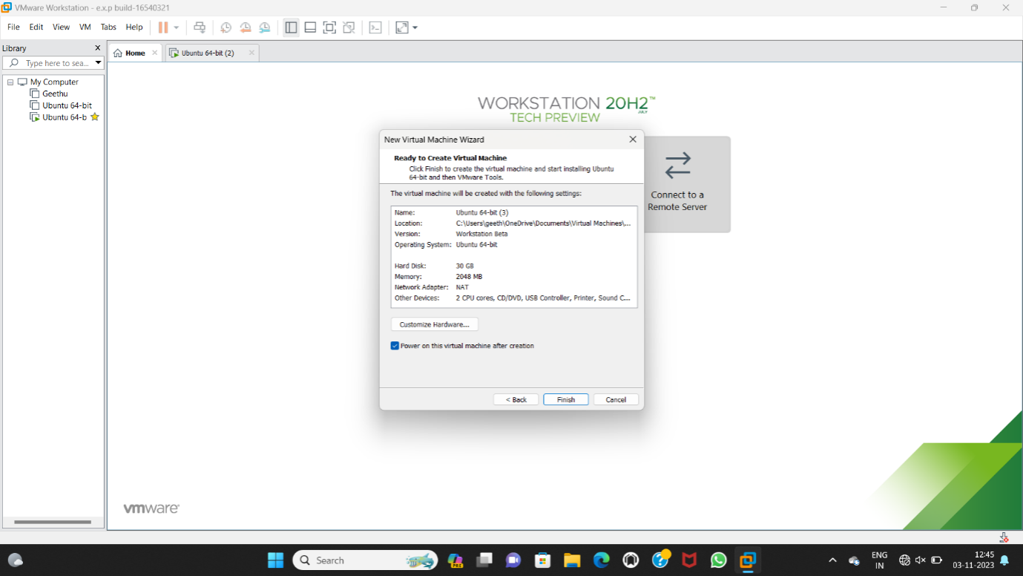

**Step 6:**

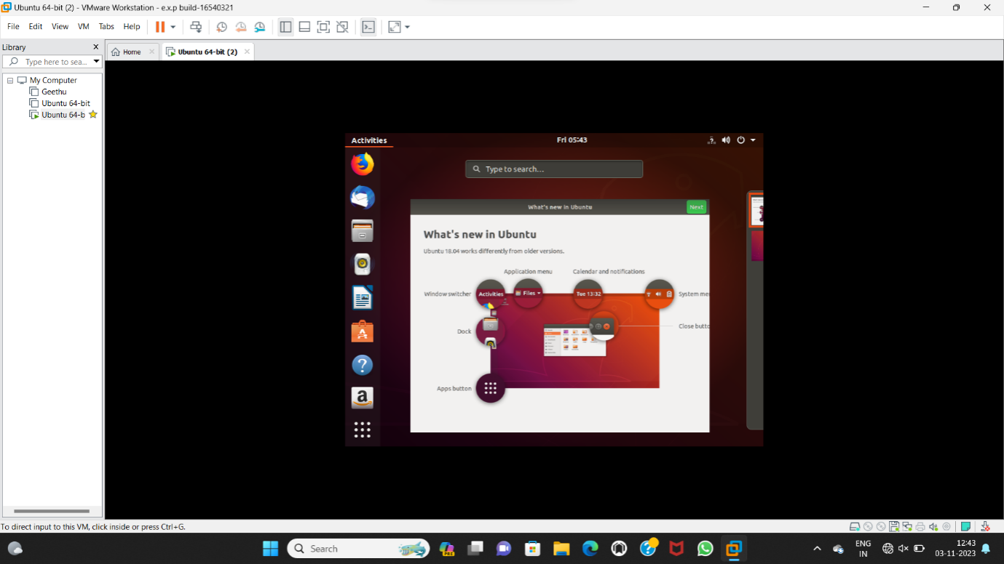

**Result:**

Successfully configure VM image with a Host Operating system Linux with vm ware workstation ensures scalable, secure, and integrated solutions for seamless user experiences**.**